1. 
2. A close up of a document

   Description automatically generated
3. **Why Confluence Schema Registry**:
4. A diagram of a diagram

   Description automatically generated
5. A screenshot of a computer program

   Description automatically generated
6. 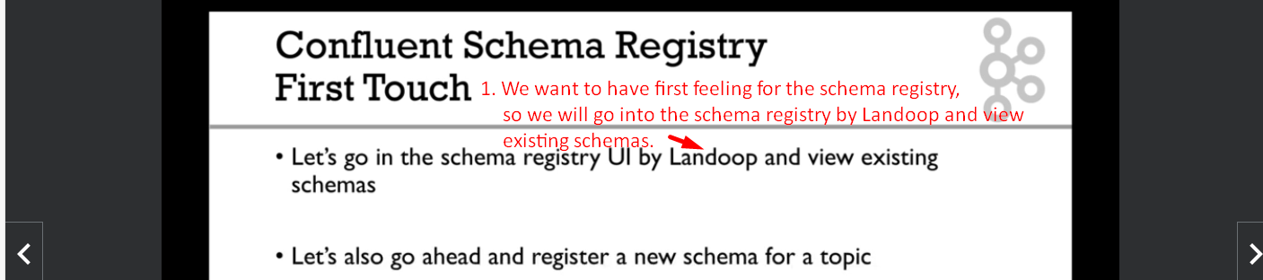
7. Let’s open Landoop.
   1. **On Docker Desktop**:
      1. localhost:3030
   2. **For Docker Toolbox**:  
      
8. A screenshot of a computer

   Description automatically generated
9. A screenshot of a computer

   Description automatically generated
10. A screenshot of a computer

    Description automatically generated
11. A screenshot of a computer

    Description automatically generated
12. A screenshot of a computer

    Description automatically generated
13. A screenshot of a computer

    Description automatically generated
14. A screenshot of a computer

    Description automatically generated
15. A screenshot of a computer

    Description automatically generated  
      
    A screenshot of a computer

    Description automatically generated  
      
    A screenshot of a computer

    Description automatically generated
16. A screenshot of a computer

    Description automatically generated
17. A screenshot of a computer

    Description automatically generated